- This week's Treasury Select Committee hearing emphasised the deep divisions within the Monetary Policy Committee. The majority of the MPC's preoccupation with supply means the upcoming wage data will be a key influence on whether they cut again in August, and the latest Decision Maker Panel provided reassurance that pay growth is still headed in the right direction.
- Developments on the trade front will also be important. Governor Bailey suggested this was pivotal to his vote to cut in May, and this week's increase in US steel and aluminium tariffs offered a reminder about the potential for further volatility on this score.
The Bank of England's Monetary Policy Committee was unusually divided at the May meeting, and since then, most members have sought to clarify their positions. This week's Treasury Select Committee hearing provided the opportunity for four members to express their views, with the testimonies of Governor Andrew Bailey and Deputy Governor Sarah Breeden of particular interest.
The minutes of May's meeting had suggested that for some of the five members voting for a 25bps cut, the decision between cutting and holding was finely balanced until the US 'Liberation Day' tariff announcements. Governor Bailey said that he was in the group who were undecided until the news emerged from the US, but Breeden said she was already committed to cutting in May.
Bailey said that for interest rates to continue to fall, it would be "crucial" that wage growth comes down, and he felt "that path is intact". The subsequent BoE Decision Maker Panel results for May supported this view, with expectations for wage and prices growth continuing to cool. Indeed, the three-month average for expected pay growth was lower than at any time since the question was first posed in 2022 (Chart 1). May's S&P Global surveys also reported some moderation in costs and prices growth, after the increases in employers' national insurance contributions and the national living wage had caused those balances to spike up in April.
Chart 1: The BoE's survey suggested that price and wage expectations continue to cool
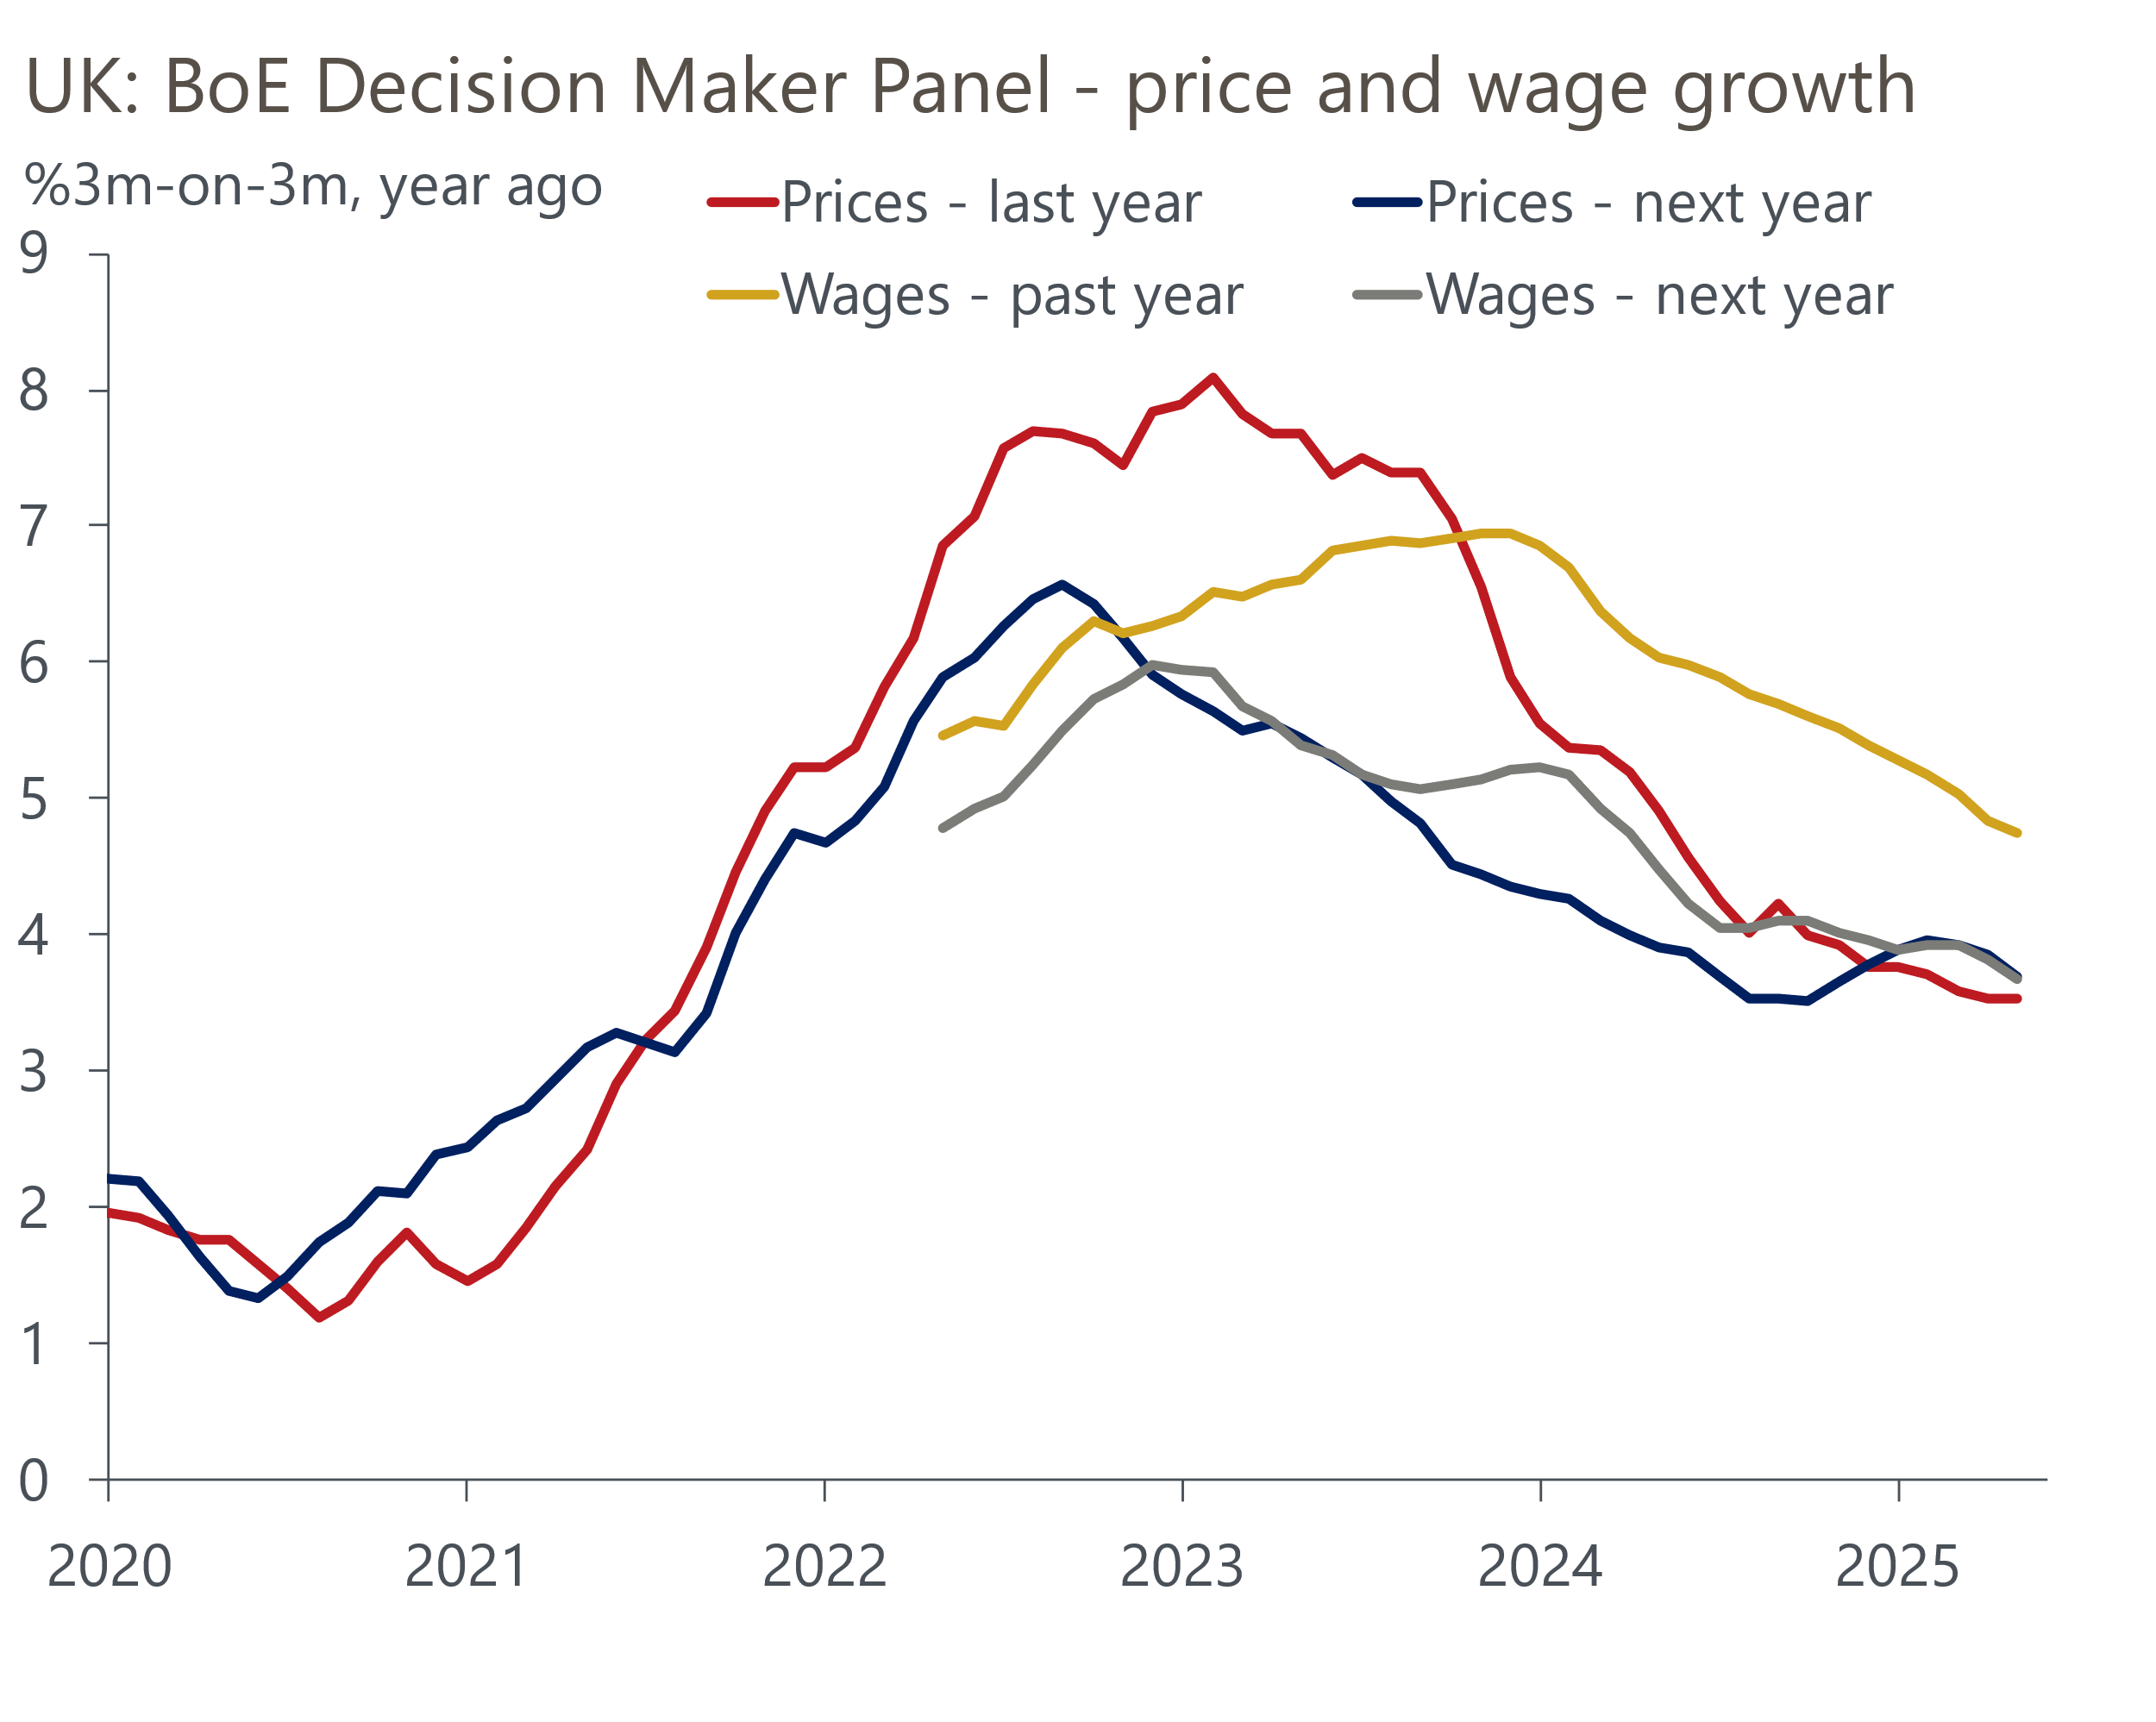
Source: Bank of England Decision Maker Panel

The Governor also played down the importance of the strong GDP outturn for Q1, pointing to the much weaker business survey results. Indeed, while this week's final PMIs for May were much stronger than April's results, they were still a clear step down from those reported for much of the past year (Chart 2). But we have less faith in the S&P Global surveys than the Governor appears to – while the surveys may be doing a reasonable job of tracking sentiment, their recent record of tracking activity has been poor.
Chart 2: Both the GDP data and the business surveys appear to suffer from major flaws
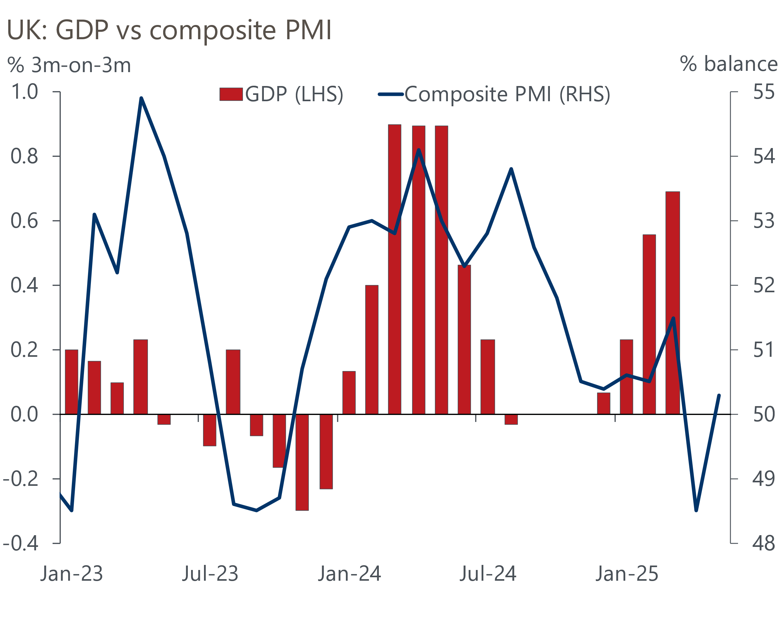
Sources: ONS, S&P Global
The June MPC meeting in a couple of weeks' time will almost certainly see Bank Rate held at 4.25%. The real interest is around the August meeting. Bailey emphasised that he felt that the direction of travel for interest rates is downwards, a point that even arch hawk Catherine Mann agreed with, but argued that the pace of cuts is "shrouded in a lot more uncertainty". Two factors are likely to be key to August's decision.
First, the MPC will see two more sets of labour market and inflation figures, with the data covering the period since the NICs and NLW rises went into force. Confidence in the quality of official data took another knock this week, with the news that the Office for National Statistics had discovered an error in the data that had been supplied by the Department for Transport to calculate the vehicle excise duty element of April's inflation data. April's outturn for CPI inflation should have been 3.4%, not 3.5%. The ONS has decided not to revise the April estimate but will use the correctly weighted data from May. So underlying price pressures are not quite as heated as they had previously appeared.
Second, there's plenty of scope for US trade policy to shape the MPC's thinking. The US government announced this week that steel and aluminium tariffs would rise to 50%, from 25%. Tariffs on imports of these goods from the UK will remain at 25% for now, in recognition of the recent trade deal, but will rise to 50% on July 9 if the US decides there hasn't been sufficient progress in finalising the trade deal. With the courts still deliberating on other US tariffs, and the potential for further announcements from the White House, the situation remains unpredictable.
On balance, we still think that another 25bps cut in August is a good bet. But Bailey's revelation that he was actively considering voting for no change in May has left us slightly less certain about that call.
Finally, the government offered some hints about forthcoming changes to fiscal policy ahead of next week's spending review. The Chancellor confirmed that the government will reinstate winter fuel payments to some pensioners this year, and there has also been more chatter about ending the two-child benefit cap. Given there's already a strong chance that unfavourable Office for Budget Responsibility forecast revisions will leave the government needing to make more fiscal savings, the likelihood of large tax rises in the autumn Budget continues to rise. And that's before we factor in any increase in defence spending beyond the 2.5% of GDP commitment that the spending review will be based on. This week's Strategic Defence Review laid out a lengthy list of recommendations that will be very costly to implement, while there remains a very real prospect that the NATO target is set much higher at its summit later this month.

The week ahead
There are two major Office for National Statistics releases next week.
Tuesday's labour market release will offer the first indication of the impact of April's increases in employers' national insurance contributions and the national living wage on the main ONS series. The big increase in the NLW will have pushed up pay growth at the lower end of the income distribution, but we expect some offset further up the distribution from firms seeking to limit the increase in labour costs caused by the NICs increase. Strong base effects should also prevent a pickup in headline (three-month average of the annual rate) wage growth. We expect total pay to come in at 5.5%, with regular pay growth at 5.4%.
With January's soft reading set to fall out of the three-month average, we expect the Labour Force Survey measure of unemployment will rise to 4.6% in the three months to April.
Recent monthly GDP readings have been surprisingly strong, with residual seasonality likely to be playing a key role. In three of the 20 sectors covered in the ONS release, annualised output growth in Q1 exceeded 10%, while another four were in the 6%-8% range. But our reading of UK economic data suggests that underlying conditions are nowhere near this strong, so we expect there to be some payback over the rest of this year, beginning in April. We pencil in a 0.2% month-on-month decline in GDP in April.
Table 1: Week ahead calendar
Date | Events | Period | Measure | Unit | Previous | Forecast
Jun 10 | LFS unemployment | Feb-Apr | Rate | % | 4.5 | 4.6
Jun 10 | Average earnings (total pay) | Apr | 3m, y/y | % | 5.5 | 5.5
Jun 10 | Average earnings (regular pay) | Apr | 3m, y/y | % | 5.6 | 5.4
Jun 12 | GDP | Apr | m/m | % | 0.2 | -0.2
Jun 12 | GDP | Apr | 3m/3m | % | 0.7 | 0.7
Jun 12 | Index of services | Apr | m/m | % | 0.4 | -0.2
Jun 12 | Index of services | Apr | 3m/3m | % | 0.7 | -0.7
Jun 12 | Manufacturing output | Apr | m/m | % | -0.8 | -0.5
Jun 12 | Manufacturing output | Apr | y/y | % | -0.8 | 0.7
Jun 12 | Industrial production | Apr | m/m | % | -0.7 | -0.4
Jun 12 | Industrial production | Apr | y/y | % | -0.7 | -0.2
Jun 12 | Construction output | Apr | m/m | % | 0.5 | 0.0
Jun 12 | Construction output | Apr | y/y | % | 1.4 | 2.3
Jun 12 | UK trade | Apr | Trade balance | £bn | -3.7 | -4.0
Jun 12 | UK trade | Apr | Visible balance | £bn | -19.9 | -20.2
Source: Oxford Economics

Key forecasts
Table 2: UK forecast overview
(Annual percentage changes unless specified)
 | 2023 | 2024 | 2025 | 2026 | 2027 | 2028
GDP | 0.4 | 1.1 | 1.2 | 0.9 | 1.3 | 1.8
Private consumption | 0.5 | 0.6 | 1.0 | 1.2 | 1.3 | 1.7
Fixed investment | 0.3 | 1.5 | 2.0 | 0.6 | 1.6 | 2.0
Government consumption | 1.6 | 3.0 | 1.5 | 1.7 | 1.6 | 1.7
Exports of goods and services | -0.4 | -1.2 | 0.9 | -1.3 | 1.2 | 1.5
Imports of goods and services | -1.2 | 2.7 | 1.5 | -1.0 | 1.1 | 1.4
Industrial Production | -0.8 | -1.2 | 0.0 | -0.3 | 0.7 | 1.2
Consumer prices | 7.3 | 2.5 | 3.2 | 2.5 | 2.4 | 2.1
Unemployment rate (%) | 4.1 | 4.3 | 4.6 | 4.8 | 4.8 | 4.4
Current a/c balance (% of GDP) | -3.5 | -2.7 | -2.7 | -2.7 | -2.6 | -2.6
Government balance (% of GDP) | 5.2 | 5.1 | 4.3 | 3.6 | 2.9 | 2.6
Central bank policy rate (%, EOP) | 5.25 | 4.75 | 3.75 | 3.00 | 2.50 | 2.50
10yr govt. bond yield (%, EOP) | 3.54 | 4.57 | 4.50 | 3.96 | 3.46 | 3.35
Exchange rate (US$ per £, EOP) | 1.27 | 1.25 | 1.35 | 1.35 | 1.35 | 1.35
Exchange rate (euro per £, EOP) | 1.15 | 1.21 | 1.19 | 1.19 | 1.19 | 1.19
Source: Oxford Economics
Table 3: Quarterly forecasts for the UK
 | 2025 |  |  |  | 2026
 | Q1 | Q2 | Q3 | Q4 | Q1 | Q2 | Q3 | Q4
GDP (% year) | 1.3 | 1.0 | 1.1 | 1.2 | 0.7 | 0.8 | 0.9 | 1.0
CPI inflation (% year) | 2.8 | 3.4 | 3.5 | 3.2 | 3.0 | 2.2 | 2.4 | 2.5
Bank Rate (%, EOP) | 4.50 | 4.25 | 4.00 | 3.75 | 3.50 | 3.25 | 3.25 | 3.00
10yr gilt yield (%, EOP) | 4.70 | 4.70 | 4.61 | 4.50 | 4.37 | 4.25 | 4.11 | 3.96
US$ per £ (EOP) | 1.29 | 1.35 | 1.35 | 1.35 | 1.35 | 1.35 | 1.35 | 1.35
Euro per £ (EOP) | 1.20 | 1.19 | 1.19 | 1.19 | 1.19 | 1.19 | 1.19 | 1.19
Source: Oxford Economics

Latest Country Economic Forecast:
May 20, 2025

Recent publications

Data Insights
Q2 GDP growth expected to outperform the PMIs
March's surge in mortgage lending unwound in April's data
Challenges for the manufacturing sector remain
Retail sales surged again in April
PMI rebounds in May, but likely remains too downbeat

Research Briefings
Tough fiscal choices looming in the Autumn
What the EU deal means for trade and growth
Employment nowcast suggests limited impact from NICs rise
MPC stays on its "gradual and careful" path
MPC Preview – tariffs could prompt a less cautious approach

Contacts

Oxford Economics' UK team
- Andrew Goodwin - Chief UK Economist - agoodwin@oxfordeconomics.com
- Edward Allenby - UK Economist - eallenby@oxfordeconomics.com

